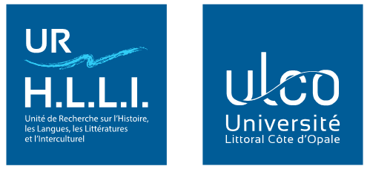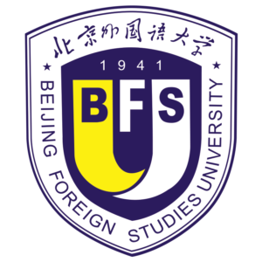

International Symposium
The Silk Roads and Exchanges between East and West, from Antiquity to the Present Day

Boulogne-sur-Mer, France, 28-30 September 2021

Organising Institutions
The Research Unit for History, Languages, Literatures and Intercultural Studies (UR 4030 HLLI), University of the Littoral Côte d’Opale (ULCO), France
In collaboration with the International Institute of Chinese Studies (IICS), Beijing Foreign Studies University (BFSU), China

Organising Committee
Li Ma (Associate Professor-HDR/Accreditation to Supervise Research, ULCO, UR 4030 HLLI) : Symposium Director
Jacqueline Bel (Professor, ULCO, UR 4030 HLLI)
Michael Murphy (Associate Professor, ULCO, UR 4030 HLLI)
Jean-Louis Podvin (Professor, ULCO, UR 4030 HLLI)
Yan Liang (Professor, BFSU, IICS)
Yongqian Guan (Associate Professor, BFSU, IICS)

The Scientific committee is composed of renowned specialists from different countries.

Presentation
The "Silk Road" linked Xi'an, the ancient Chinese imperial capital of the Han dynasty, to ancient Rome, from the early 2nd century BC. Named by the 19th century German geographer Ferdinand Von Richthofen, the "Silk Road" was a set of land and sea trade routes linking Asia, Africa and Europe, a bridge between the civilisations of East and West, a privileged channel for the communication of political, philosophical, cultural and religious ideas, and for the dissemination of scientific progress. It was gradually abandoned after the opening of the Spice Route by Europe.
In 2013, the Chinese government launched the "One Belt, One Road" project to create a Eurasian "economic corridor" - that already crosses more than 65 countries - linking China to Western Europe by land and by sea (the China Sea, the Indian Ocean and the Mediterranean). Based on the historical prestige of the ancient route, this land "belt" and the "Maritime Silk Road Policy of the 21st Century" represent a "Chinese-style" globalisation project that aims to forge new links between Asia, Africa and Europe and unite their land and sea trade routes.
The Silk Roads have played an important role in trade between East and West and in the rapprochement of civilisations, and renewed efforts have reinforced these orientations.
This scientific event aims to examine more closely the various exchanges between States and Peoples from antiquity to the present day, and to analyse the many reasons for this development, which has opened up new horizons. The aim of the symposium is to take stock of research on the different Silk Roads, to examine the current strategic, economic and geopolitical stakes of such research.
The idea is to produce a synthesis of research on the subject, by bringing together specialists from different disciplines (history, intercultural studies, political science, science of religions, history of art, archaeology, economics, linguistics, geography, mathematics, medicine, sinology). Such interdisciplinary and multidisciplinary cross-checking will ensure new results.

Call for Papers
The conference will focus on papers on the following four themes:
- The Silk Roads: the diversity of exchanges and the civilising dimension
- The Silk Roads and Empires
- Travellers on the Silk Roads
- The OBOR project in a changing world

The Scientific committee will consider all subjects concerning the study of the Silk Roads and Exchanges between East and West. Evaluations of existing research are welcome.

To submit proposals, please send a 300 word abstract and a one-page CV (using the attached form) to: li.ma@univ-littoral.fr
Submission deadline: 30 April 2021

Symposium Languages
Presentations will be in French or English, or Chinese (exceptionally).

Publication
The proceedings of the symposium will be published in the form of a collective work after selection by an international reading committee. A review will be published in Les Cahiers du Littoral and the Journal of International Institute of Chinese Studies.
Site Symposium : http://www.echanges.orientoccident.fr
***

Abstract Submission Form

International Symposium
The Silk Roads and Exchanges between East and West, from Antiquity to the Present Day

Name
Institutional affiliation
Position
Address |  | Email
Paper Title
Abstract (not more than 300 words)

The ABSTRACT should be accompanied by a short CV (Institution, Position, Address, Nationality, Education, Research Interests, Selected publications, 1 page maxi), both to be sent before 30 April 2021, to: li.ma@univ-littoral.fr

